Q1. Query all columns for all American cities in the CITY table with populations larger than 100000. The CountryCode for America is USA.

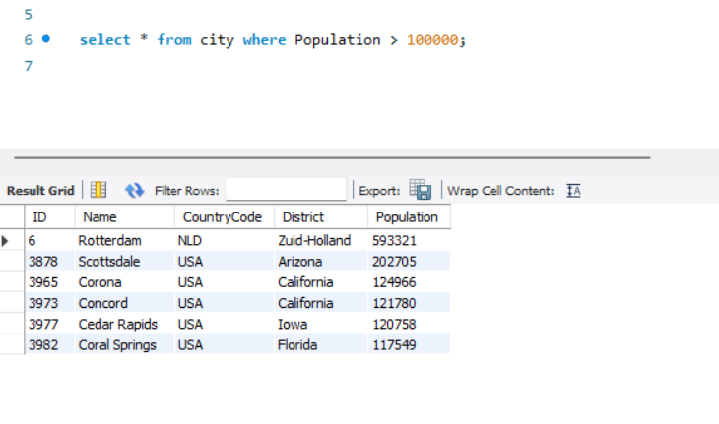

Q2. Query the NAME field for all American cities in the CITY table with populations larger than 120000. The CountryCode for America is USA.

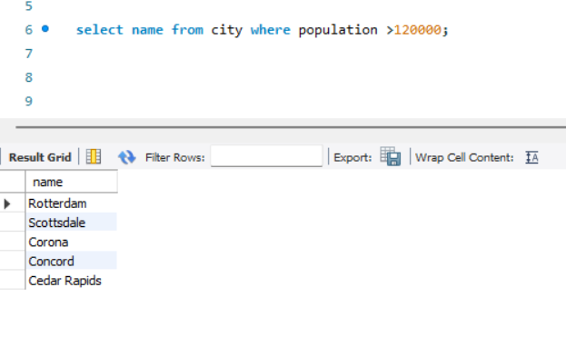

Q3. Query all columns (attributes) for every row in the CITY table.

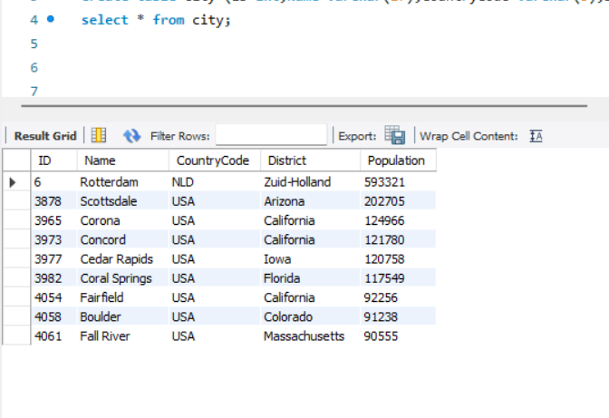

Q4. Query all columns for a city in CITY with the ID 1661.

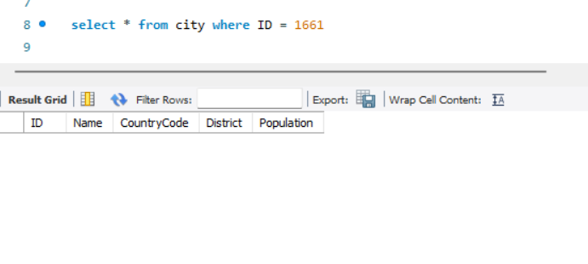

Q5. Query all attributes of every Japanese city in the CITY table. The COUNTRYCODE for Japan is JPN.

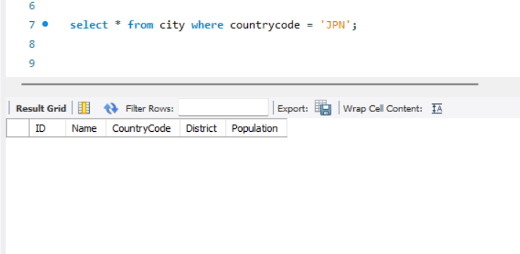

6. Query the names of all the Japanese cities in the CITY table. The COUNTRYCODE for Japan is JPN

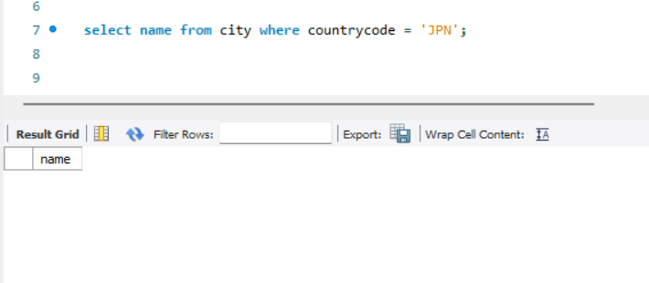

Q7. Query a list of CITY and STATE from the STATION table

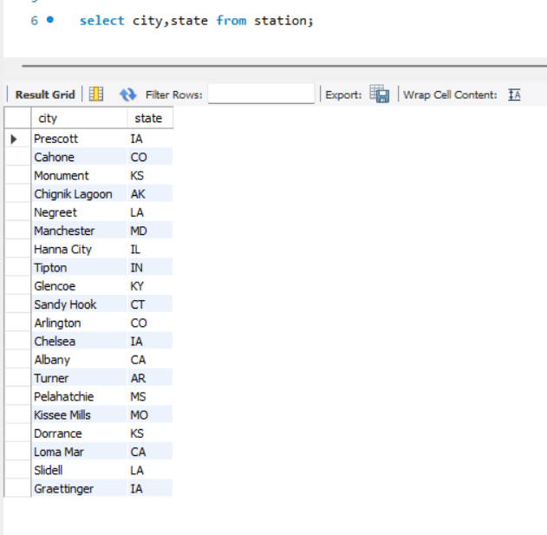

Q8. Query a list of CITY names from STATION for cities that have an even ID number. Print the results in any order, but exclude duplicates from the answer.

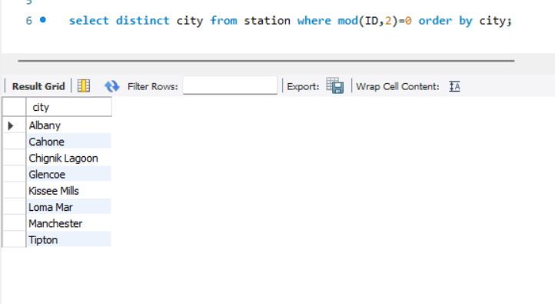

Q9. Find the difference between the total number of CITY entries in the table and the number of distinct CITY entries in the table.

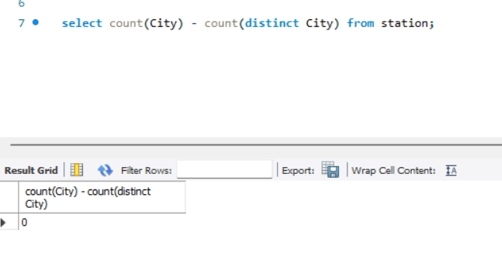

Q10. Query the two cities in STATION with the shortest and longest CITY names, as well as their respective lengths (i.e.: number of characters in the name). If there is more than one smallest or largest city, choose the one that comes first when ordered alphabetically.

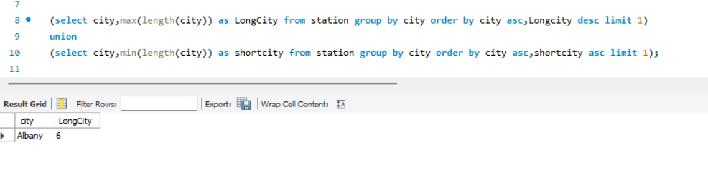

Q11. Query the list of CITY names starting with vowels (i.e., a, e, i, o, or u) from STATION. Your result cannot contain duplicates.

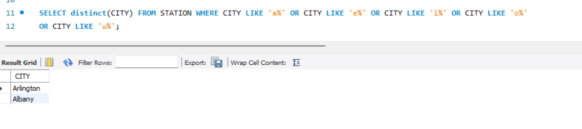

Q12. Query the list of CITY names ending with vowels (a, e, i, o, u) from STATION. Your result cannot contain duplicates.

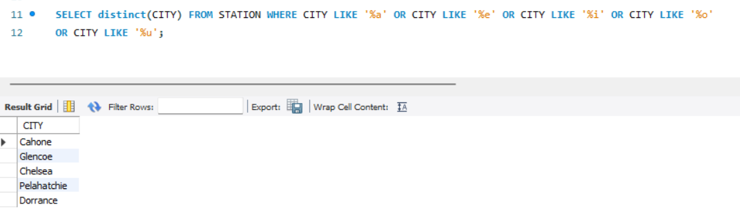

Q13. Query the list of CITY names from STATION that do not start with vowels. Your result cannot contain duplicates.

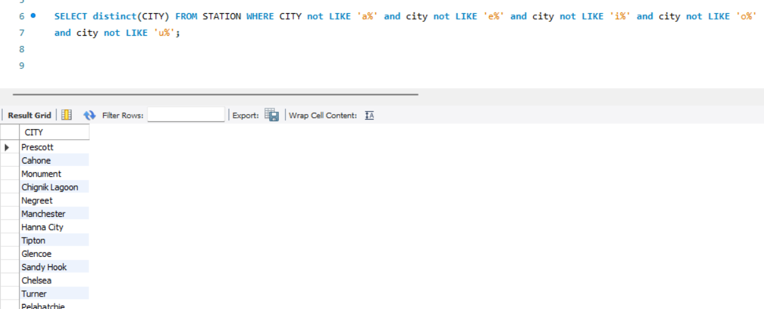

Q14. Query the list of CITY names from STATION that do not end with vowels. Your result cannot contain duplicates.

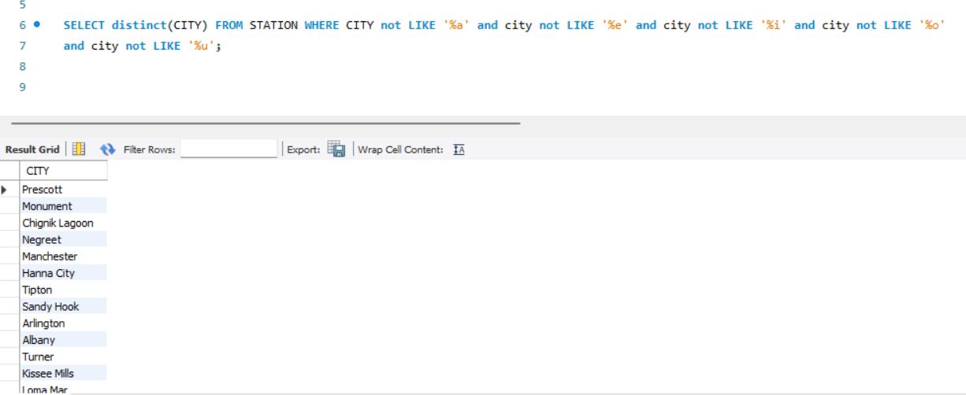

Q15. Query the list of CITY names from STATION that either do not start with vowels or do not end with vowels

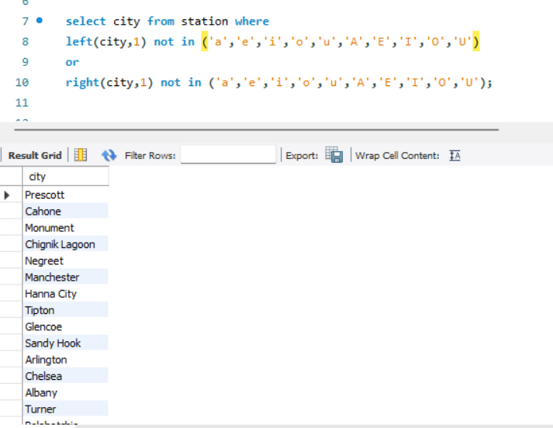

Q16. Query the list of CITY names from STATION that do not start with vowels and do not end with vowels

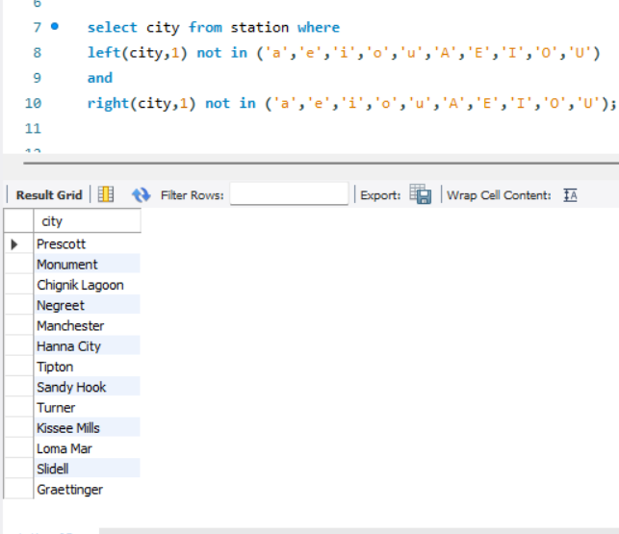

Q17.Write an SQL query that reports the products that were only sold in the first quarter of 2019. That is, between 2019-01-01 and 2019-03-31 inclusive.

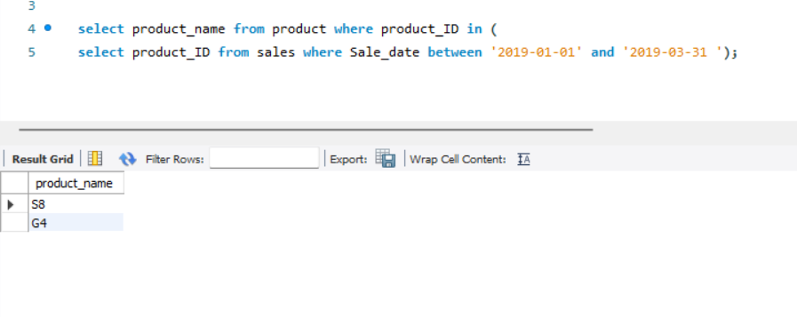

Q18.Write an SQL query to find all the authors that viewed at least one of their own articles. Return the result table sorted by id in ascending order.

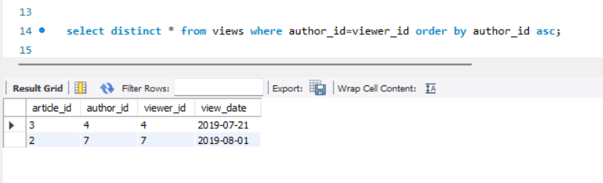

Q19.Write an SQL query to find the percentage of immediate orders in the table, rounded to 2 decimal places

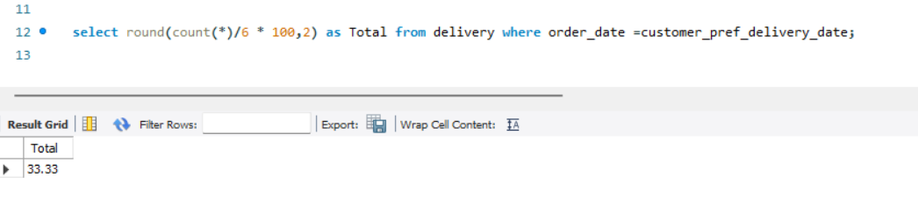

Q20.Write an SQL query to find the ctr of each Ad. Round ctr to two decimal points. Return the result table ordered by ctr in descending order and by ad_id in ascending order in case of a tie.

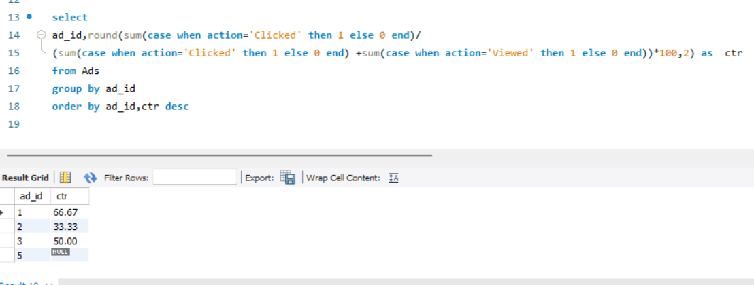

Q21. Write an SQL query to find the team size of each of the employees.

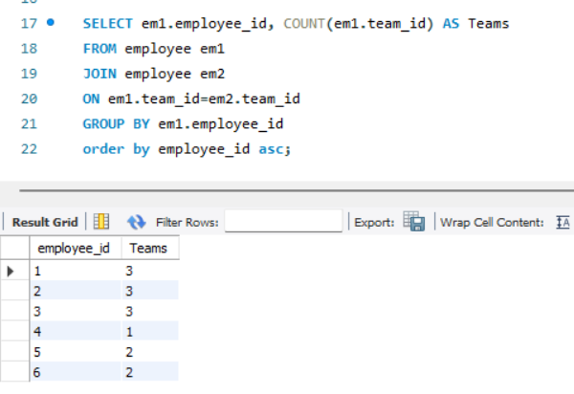

Q22.Write an SQL query to find the type of weather in each country for November 2019. The type of weather is:

● Cold if the average weather_state is less than or equal 15,

● Hot if the average weather_state is greater than or equal to 25, and

● Warm otherwise.

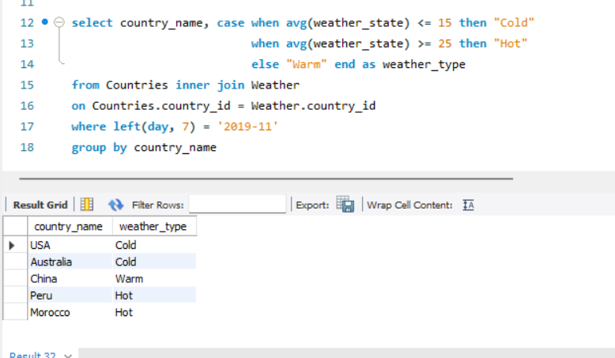

Q23.Write an SQL query to find the average selling price for each product. average_price should be rounded to 2 decimal places.

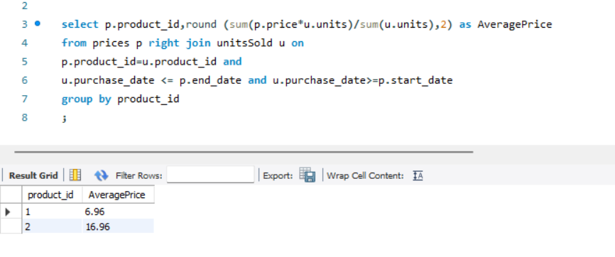

Q24. Write an SQL query to report the first login date for each player

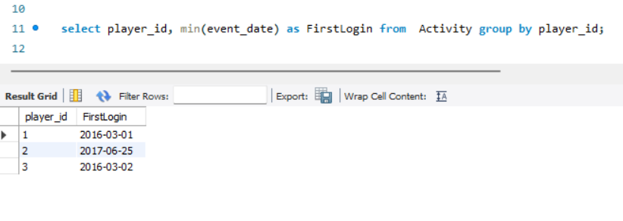

Q25. Write an SQL query to report the device that is first logged in for each player.

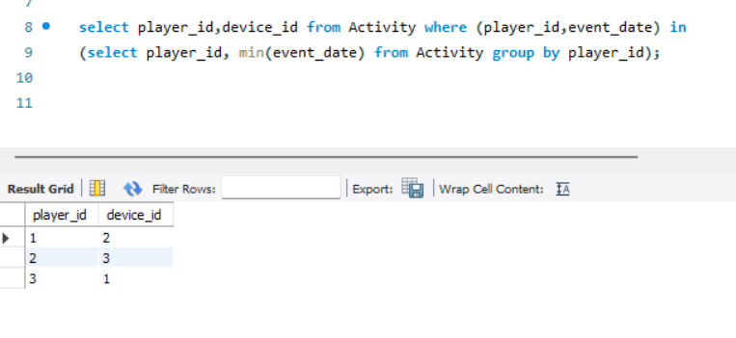

Q26. Write an SQL query to get the names of products that have at least 100 units ordered in February 2020 and their amount.

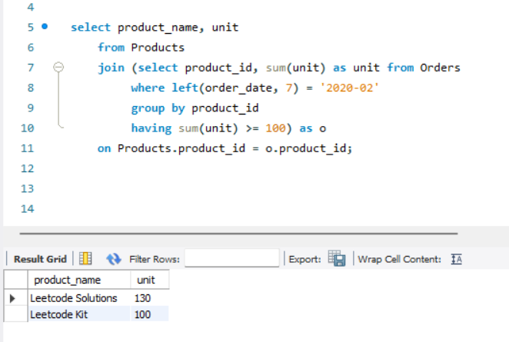

Q27. Write an SQL query to find the users who have valid emails.

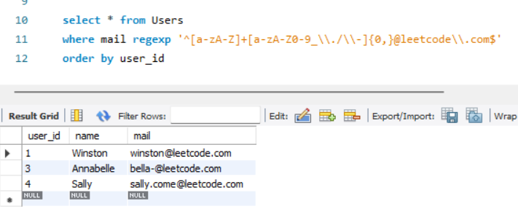

Q28. Write an SQL query to report the customer_id and customer_name of customers who have spent at least $100 in each month of June and July 2020.

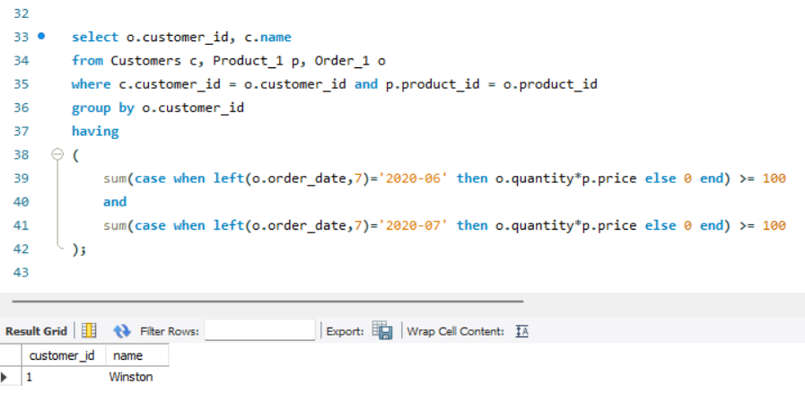

Q29. Write an SQL query to report the distinct titles of the kid-friendly movies streamed in June 2020.

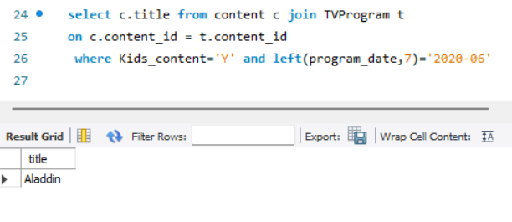

Q30. Write an SQL query to find the npv of each query of the Queries table.

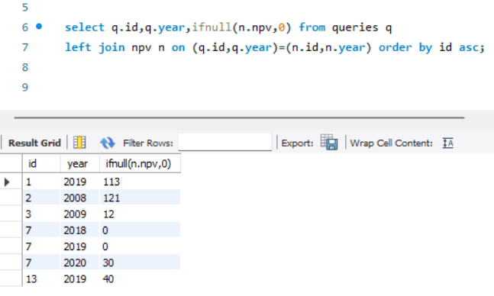

Q32. Write an SQL query to show the unique ID of each user, If a user does not have a unique ID replace just show null.

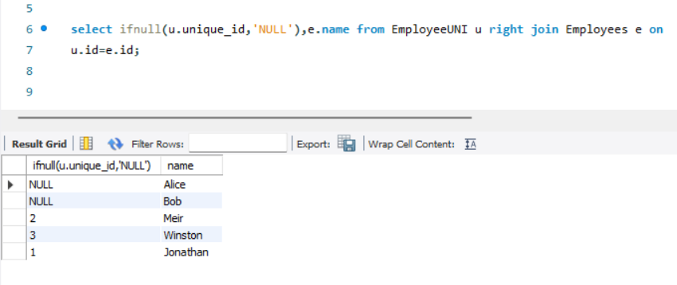

Q33.Write an SQL query to report the distance travelled by each user.

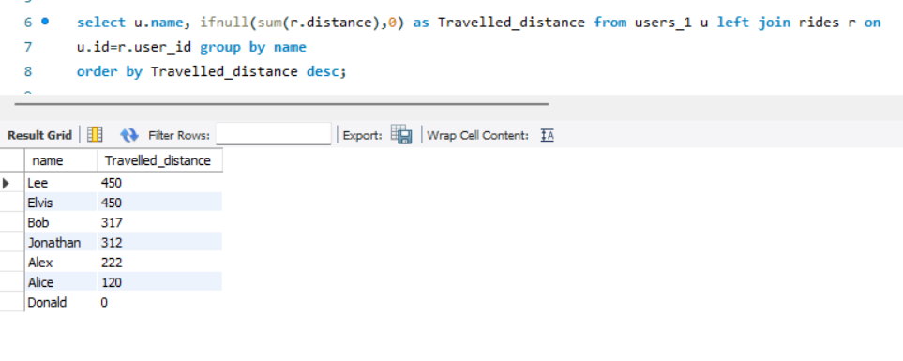

Q35. Write an SQL query to:

● Find the name of the user who has rated the greatest number of movies. In case of a tie, return the lexicographically smaller user name.

● Find the movie name with the highest average rating in unique 2020. In case of a tie, return the lexicographically smaller movie name.

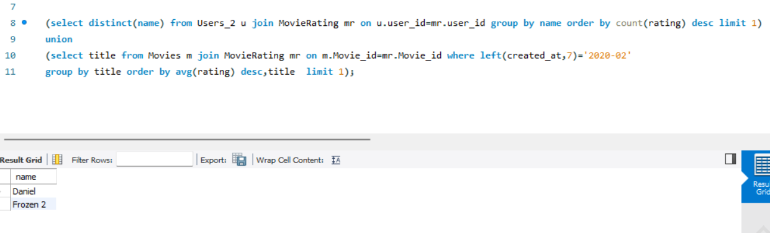

Q36. Write an SQL query to report the distance travelled by each user. Return the result table ordered by travelled_distance in descending order, if two or more users travelled the same distance, order them by their name in ascending order.

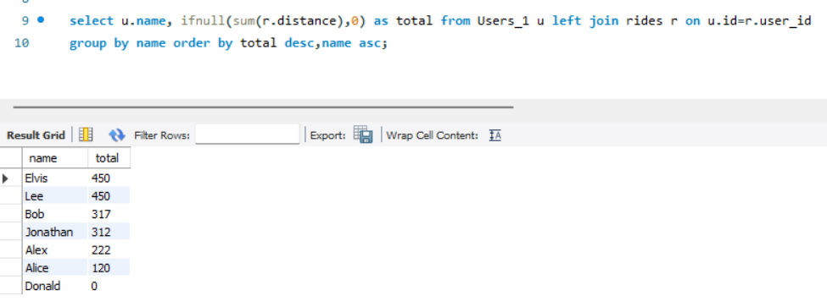

Q38. Write an SQL query to find the id and the name of all students who are enrolled in departments that no longer exist.

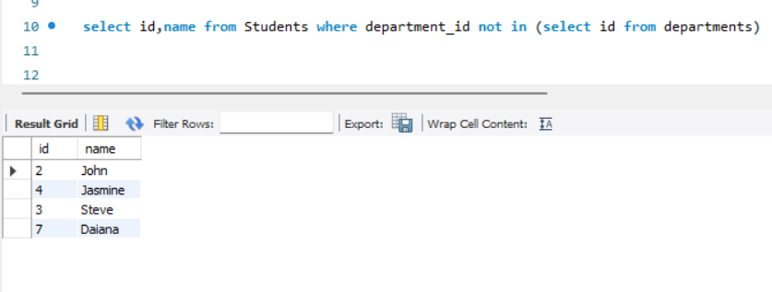

Q39. Write an SQL query to report the number of calls and the total call duration between each pair of distinct persons (person1, person2) where person1 < person2

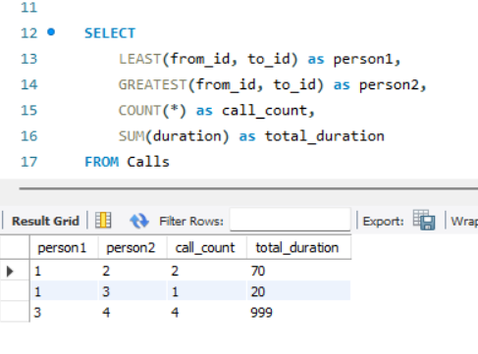

Q41. Write an SQL query to report the number of cubic feet of volume the inventory occupies in each warehouse

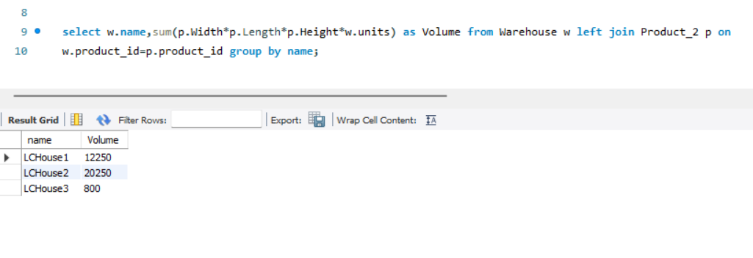

Q42. Write an SQL query to report the difference between the number of apples and oranges sold each day. Return the result table ordered by sale_date.

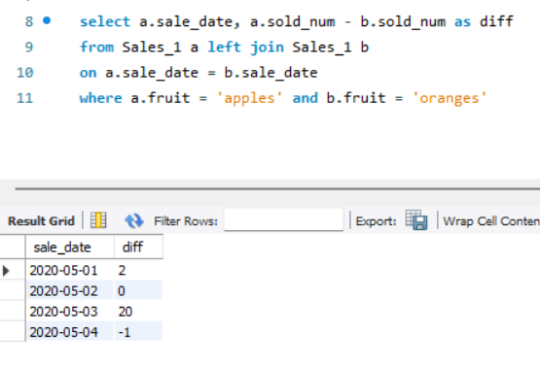

Q43. Write an SQL query to report the fraction of players that logged in again on the day after the day they first logged in, rounded to 2 decimal places. In other words, you need to count the number of players that logged in for at least two consecutive days starting from their first login date, then divide that number by the total number of players.

Q44. Write an SQL query to report the managers with at least five direct reports.

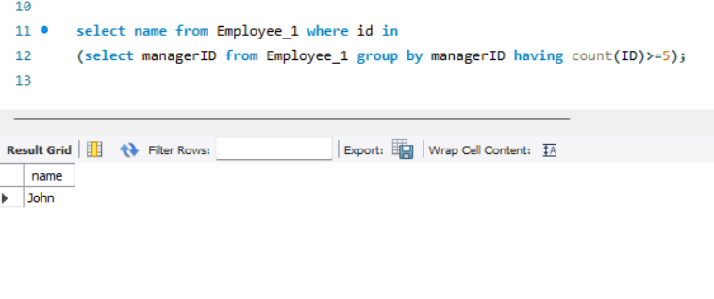Q45.Write an SQL query to report the respective department name and number of students majoring in each department for all departments in the Department table (even ones with no current students). Return the result table ordered by student_number in descending order. In case of a tie, order them by dept_name alphabetically.

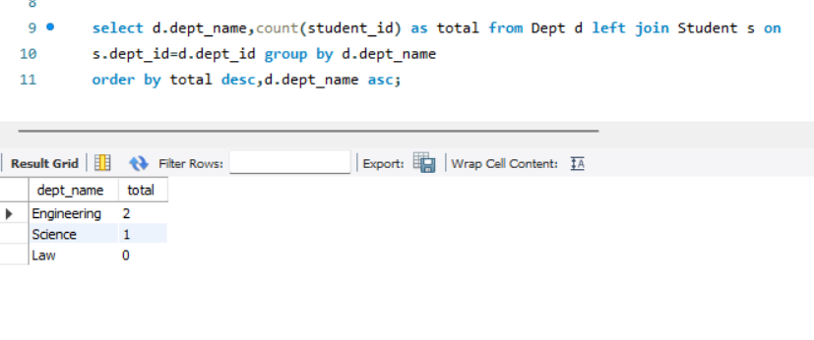

Q46.Write an SQL query to report the customer ids from the Customer table that bought all the products in the Product table.

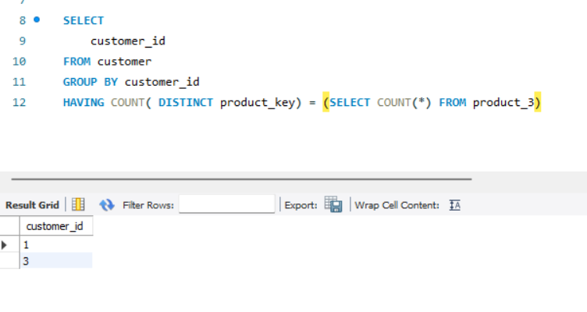

Q47.Write an SQL query that reports the most experienced employees in each project. In case of a tie, report all employees with the maximum number of experience years.

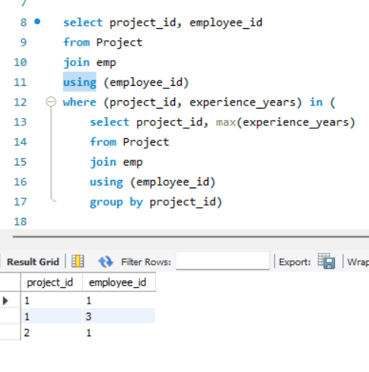

Q48. Write an SQL query that reports the books that have sold less than 10 copies in the last year, excluding books that have been available for less than one month from today. Assume today is 2019-06-23.

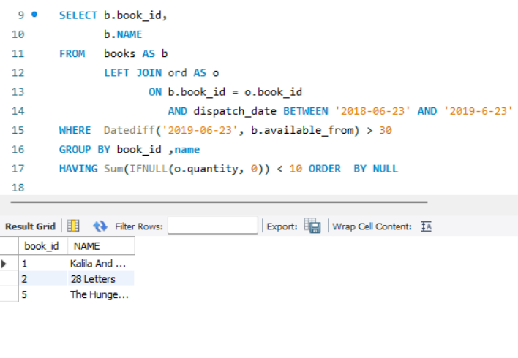

Q49. Write a SQL query to find the highest grade with its corresponding course for each student. In case of a tie, you should find the course with the smallest course_id.

